**Chinese Martial Arts Interclub**

**Competitors Pack 2025**



**Wushu Interclub Pack 2025**

**UK Shaolin Centre**

**Unit 81a**

**Marlands Shopping Centre**

**Above Bar St**

**Southampton**

**SO14 7FE**

**Sunday 22nd June 2025**

**Chinese Martial Arts Wushu Interclub**

**LOCATION**

**Find us:** [**https://ukshaolin.com/visit-us/**](https://ukshaolin.com/visit-us/)

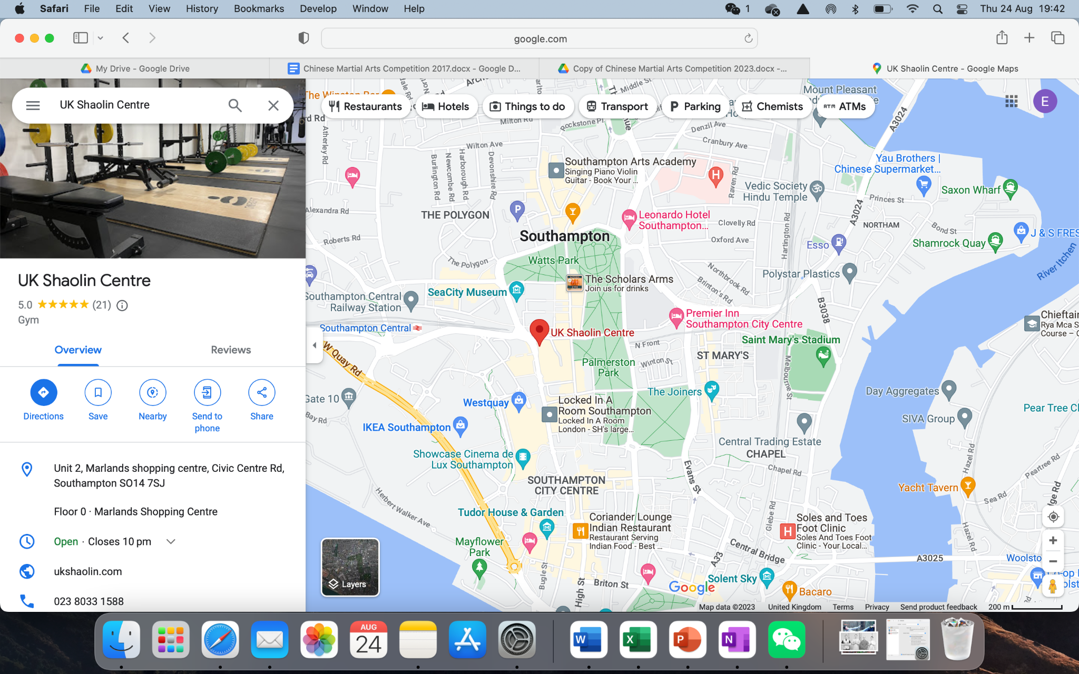

UK Shaolin Centre

Unit 81,

Marlands Shopping Centre,

ABOVE BAR ST,

Southampton

SO14 7FG

**ORGANISER**

UK Shaolin Centre (UKSC)

**INFORMATION**

Open Wushu Taolu (Modern & Traditional) – **Chinese Martial Arts Interclub**  arranged by UK Shaolin Centre, Southampton, UK.

Traditional and Wushu Taolu interclub will be held on training mats.

Open to all individuals, schools, clubs and federations.

**WHO CAN ENTER THIS INTERCLUB**

* You are registered with your club and or association
* You are a member of an association who is a member of the BCCMA.
* You have a current BCCMA license or have a valid recognised martial arts license.
* You have read and agreed to the interclub rules and event rules.
* You/parent/guardian and your coach have agreed to taking part in the interclub

**CATEGORIES**

Children and Adults

Beginners - Training for less than 1 year

Intermediate - Training for 1-3 years

Advanced - Training 4+ years

***Taolu/Forms***

Tao Lu Children 6 – 11 years - (Reg Code: THC)

Tao Lu Junior 12 – 15 years - (Reg Code: THJ)

**Tao Lu Adult +16 years**

Adults Beginners Hand Form: (Reg Code: ABH)

Adults Intermediate Hand Form: (Reg Code:AIH)

Adults Advanced Hand Form: (Reg Code: AAH)

You can perform any form of choice as long as you fall within the beginner / intermediate or advanced category.

All forms basic techniques not exceeding 1 min (i.e. Wu Bu Quan, etc).

**\*in case of low attendance categories will be merged.**

**REGISTRATION & FEES**

**Registration Deadline**

**2nd June 2025 - No registrations will be accepted after this date.**

**Participating Fees**

Children – per category £5.00

Adult – per category £10.00

**Spectator Fees**

Limited seating is available costs are as below. Tickets will be sold on door

Adults - £4.50

Children - £3.00

Family Ticket £10.00 (Two Adults Two children)

Spectator tickets can be ordered in advance.

**Payments**

All entry applications and payments must be received from the competitors

NO LATER than 2nd June 2025

(All payments received after this date will be invalid). All payments are to be made online:

**SCHEDULE**

Sunday 22nd June 2025

10.00- 10.30 – Registration

10.30 -11:00 – Open carpet for training and warm up

11.00- 16:00 – Chinese Martial Arts Interclub begins

16.00- 16.30 – Feedback session

**FILLING IN ENTRY FORM**

When filling in the form please make sure that you spell your name and dates correctly.

**CANCELED EVENTS**

If there are less than three people in any category, then they may be merged, i.e. mixed sex groups, mixed weapons. If not possible then the category will be canceled. Please make sure you fill in contact details and you will be notified.

**EQUIPMENT YOU NEED TO BRING**

**Tao Lu:**

Competitors should wear either their club uniform, which should conform to a broadly ‘Chinese Martial Arts’ style, or one of the commercially available Chinese martial arts uniforms. Appropriate shoes should be worn.

Please be aware that no outdoor shoes can be worn on the competition area site.

Only Feiyue shoes or similar to that style that have not been worn outside are acceptable.

**ACCOMMODATION**

There are many hotels and hostels situated in and around Southampton, if you need any assistance regarding your accommodation please contact event organiser

Martine Niven by e-mail [martine@ukshaolin.com](mailto:martine@ukshaolin.com) or by phone Tel: 079 3538 0789

**DISCLAIMER**

I certify that I am an official of the Association of athletes, and authorised to enter the above athlete into this event, and that the athlete is, and will be, a current member of the BCCMA or equivalent association on the day of the event. I understand that boys and girls may compete against each other in the same events and I certify that I have notified and explained the nature and risks associated with such competitions to their parents / guardians and they understand that they enter events at their own risk and own liability, and that they agree to them taking part. Our Association and those entering accept the event rules and that any events may be changed without prior notice or liability to the organisers or the UK Shaolin Temple or any other person organisation or company. Furthermore I understand and accept that entry into this event signifies my acceptance that the organiser has exclusive video rights and that the performing rights of the above named competitor are waived in favour of the organiser or its appointed agent for the purpose of video, reproduction, distribution, advertising and sale thereof.

As the parent / guardian of the athlete I confirm that I have been made aware of the event and the dangers of participation in said event and advised of all the other aspects shown above and will not hold the UK Shaolin Centre, its officers, members, the event organisers, their officers, members, or any other person associated with the event liable for any injury or losses, howsoever arising, howsoever caused, in any way, whatsoever.

Furthermore I take responsibility for the care of the below named and their behaviour at all times and accept that it shall be the athlete’s coach who shall be responsible for the monitoring of the use of the warm up practice area which will not be supervised by anyone else other than the athlete’s coaches.

The coach / parents shall also be responsible for checking the displayed entry list and making the athlete ready when the event is called. Any errors in these lists must be notified to the organisers before the competition begins. It is also noted that the organisers may merge any categories they deem necessary at their absolute discretion.